**File Handling Screenshots:-**

**GitHub Reciprocity Link**:- <https://github.com/kapildavey/Phase1.git>

**Screenshot Of Empty Folder Where File To Be Created :-**

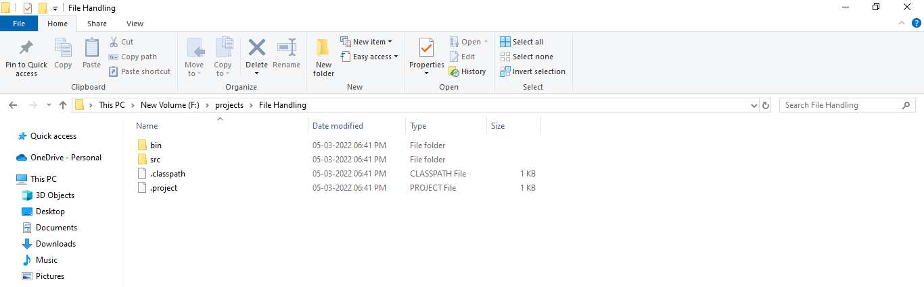

**Screenshot After File Creation Operation Is Performed :-**

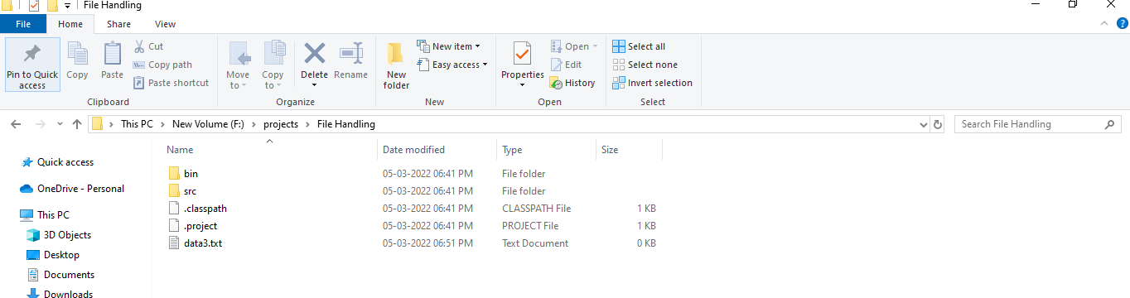

**Screenshot After Write Operation Is Performed:-**

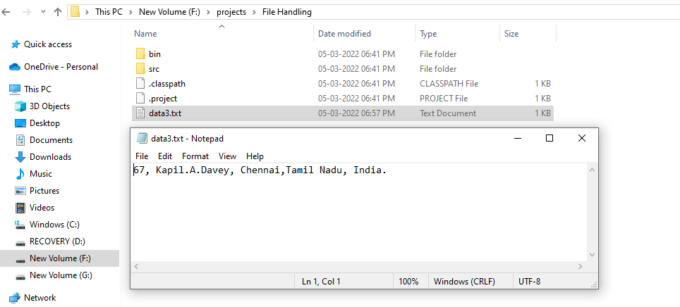

**Screenshot Of Read Operation On File:-**

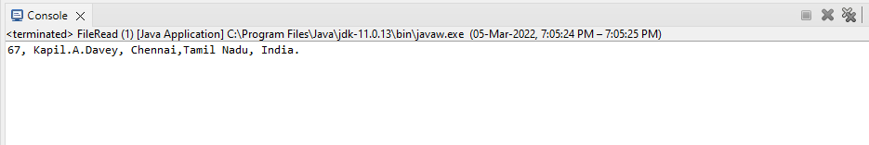

**Screenshot Of Append Operation On File:-**

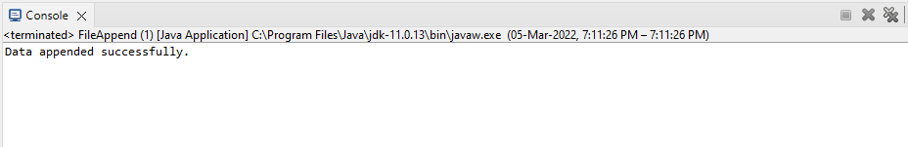

**Screenshot Of Append Operation On File:-**

